**Create And Conﬁgure IBM Cloud Service Create IBM Watson IoT Platform And Device**

STEPS

1. 1. Firstly create an IBM cloud account with IBMid and password

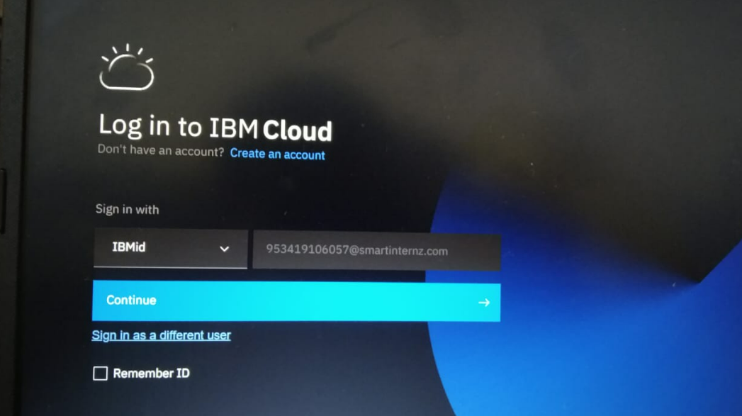

1. Home page of IBM cloud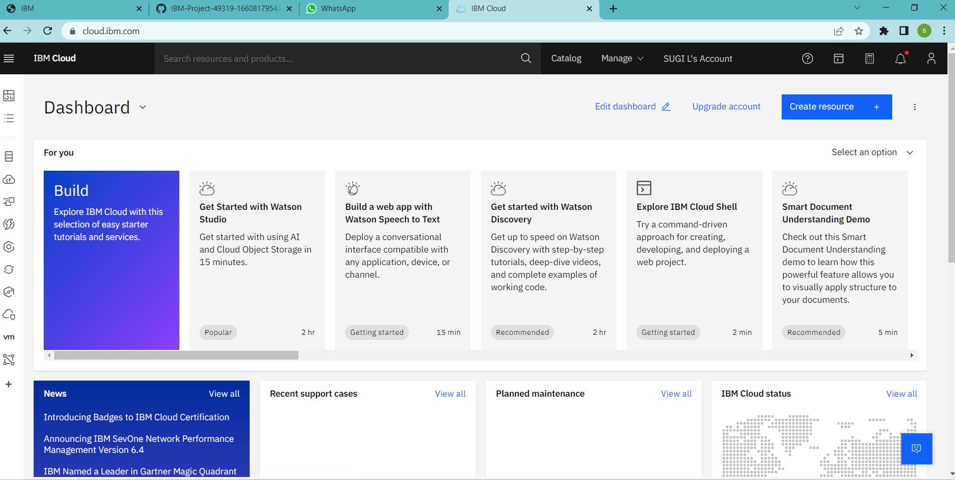
2. Click on the catalog on the top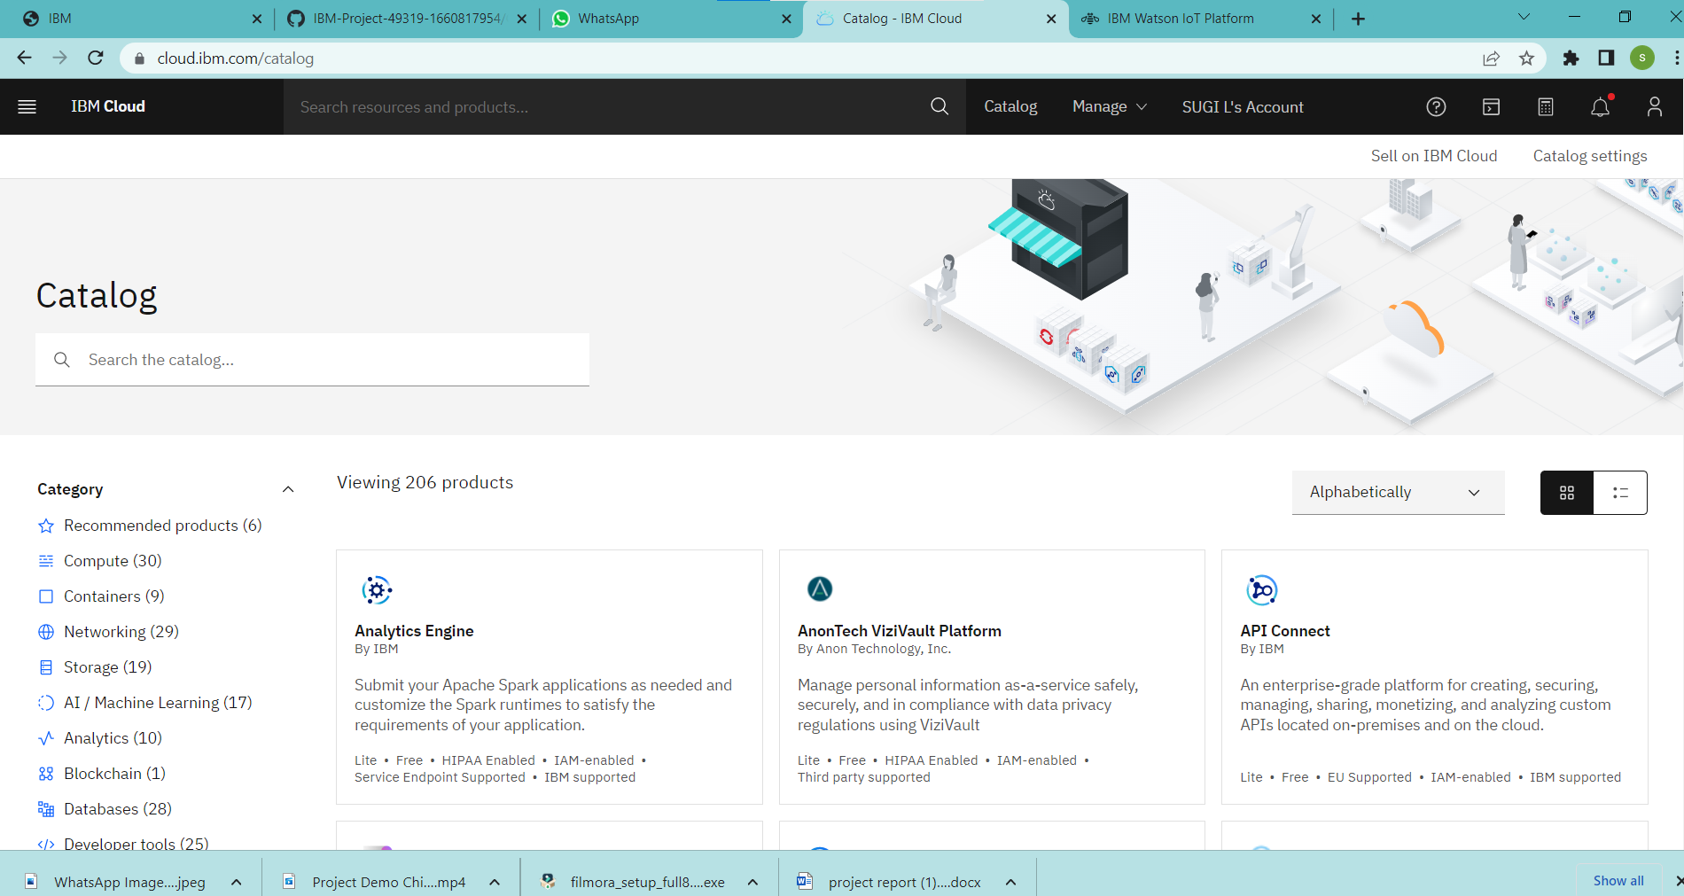
3. Click on IoT in the category mentioned

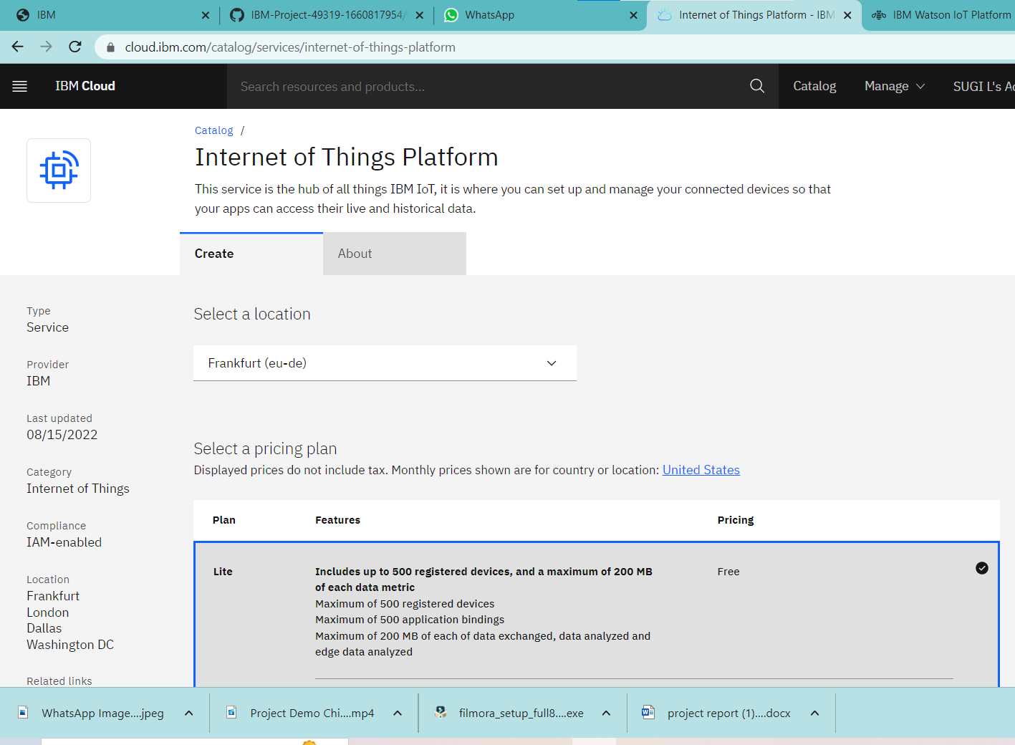

1. If already a lite is present delete it else u can’t create another.
2. Clicking on the launch button in the manage tab, it will open to this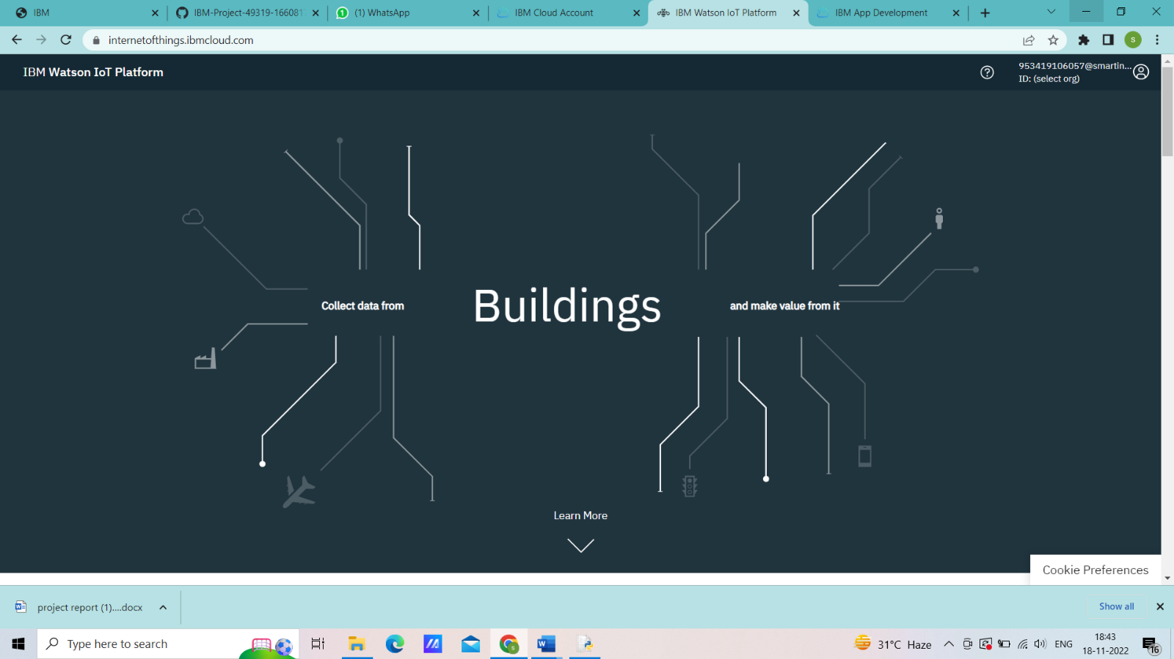
3. Enter the details to sign in to the Watson Cloud to create a device

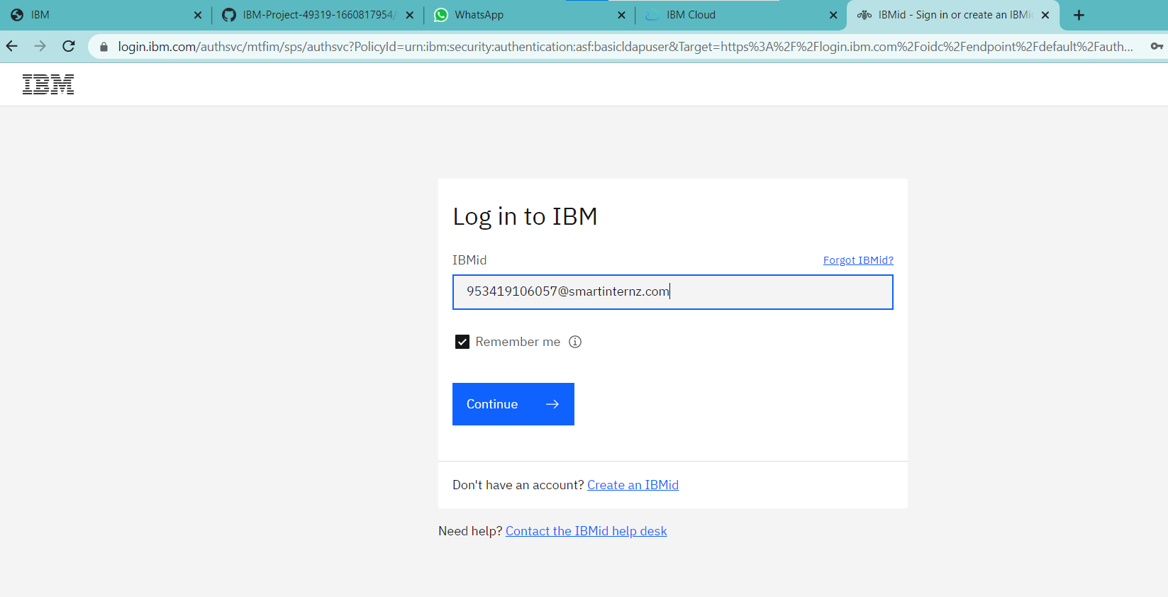

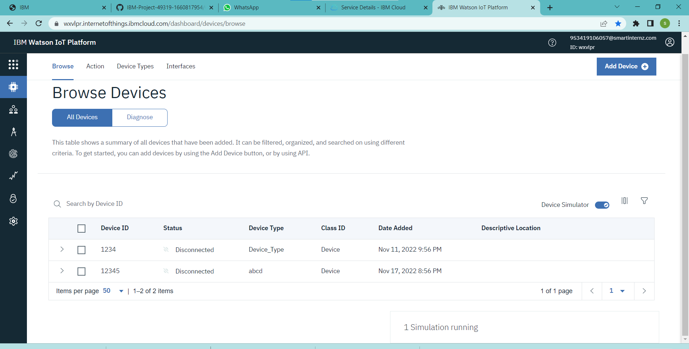

17.Clicking on next it goes to the summary of the device and click finish